Table of Contents

1) Introduction to the Electronic Regulatory Binder (eReg binder) Project 2

2) Project Layout (Home Page) 3

3) Establish eReg Binder Project 4

a) Request New Project 4

b) Open Project 4

4) Manage User Rights (Principal Investigators/Project Managers) 5

5) Enter and Store Regulatory Data 6

6) Sign-off on Delegated Tasks (Principal Investigators) 8

7) Develop Reports 8

a) Generate QI Study Management Logs 8

b) Create Site Specific Reports 9

8) Additional Features 9

a) Track Due Dates of Regulatory Documents 9

b) Display Status of Regulatory Documents 10

c) Search for Regulatory Data 10

d) Establish Links to Requirements/ Resources/Other REDCap Projects 11

# Introduction to the Electronic Regulatory Binder (eReg binder) Project

The eReg Binder is a project within REDCap that was developed by Partners Human Research Quality Improvement (QI) Program and Enterprise Research Infrastructure & Services (ERIS). The eReg Binder assists sites with the electronic storage and maintenance of regulatory documents for IRB approved protocols. This project is unique in that it contains:

* Data collection instruments that capture required regulatory information similar to what is generally captured in the print Regulatory Binder for all studies.
* Branching logic that identifies and collects study specific regulatory information, such as laboratory certifications, and FDA forms.
* A report builder for developing site specific reports including delegation of responsibility log, protocol amendment tracking log, and consent version tracking log.
* A calendar for keeping track of due-dates for regulatory documents.
* Ability for the PI to grant different levels of viewing/editing rights for study staff.

General instructions for using this REDCap project to enter and store regulatory information for an IRB approved protocol is enclosed.

# Project Layout (Home Page)

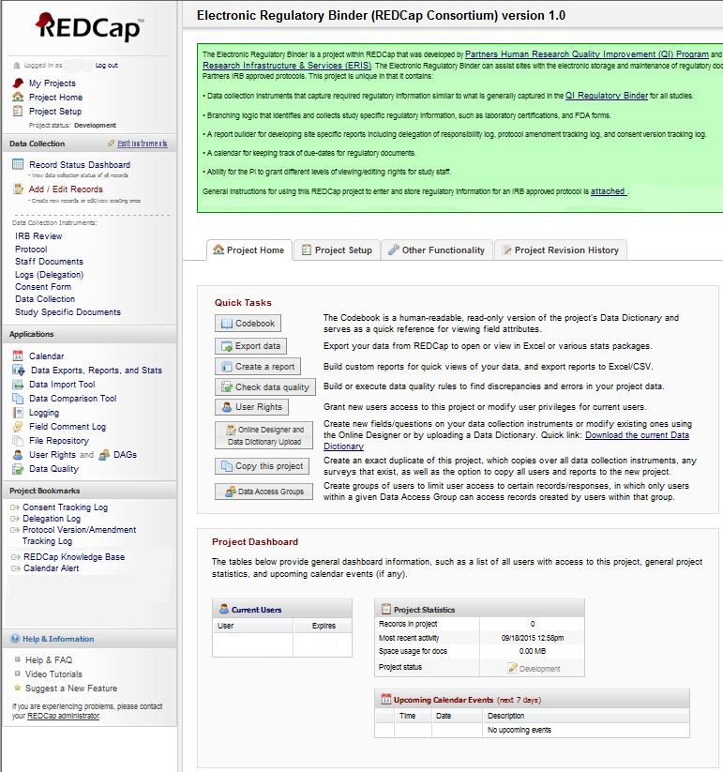

D

A

B

S

I

T

|  |  |  |  |
| --- | --- | --- | --- |
|  | **Left Navigation** |  | **Homepage** |
| D | Data collection forms for capturing regulatory data | T | Project title |
| A | Applications for managing regulatory documents (e.g. Calendar/Reports/User Rights)* | I | Intro to Electronic Regulatory Binder project (can be customized to a specific institution by REDCap Administrator) |
| B | Links to requirements, resources and other REDCap projects* | S | Summary of current users, statistics and upcoming events |

* Please note that the options in these areas may be different based on REDCap version and user rights

# Establish eReg Binder Project

## Request New Project

The eReg binder project is a general template that ***stores and maintains regulatory data for a single IRB approved protocol***. To request a template for an IRB approved protocol:

1. Log-in to REDCap using your username and password
2. Click on the tab titled “Create/Request New Project”
3. Enter a title for the project. Attaching the protocol number to the title can help study staff distinguish between projects.
4. Specify the following information, if applicable at your institution:
   * Project’s purpose
   * Protocol’s IRB status
5. To begin a project from an existing template, select the option to **“use a template”**
6. Select the template for the **“Electronic Regulatory Binder”**
7. Click on the “Send Request” button
8. Repeat steps 2-7 to request a project for another IRB approved protocol (if applicable)

## Open Project

To open a REDCap project after a request has been submitted:

1. Log-in to REDCap using your username and password
2. Under the “My Projects” Tab, click on the applicable eReg Binder project

# Manage User Rights (Principal Investigators/Project Managers)

Principal Investigators/Project Managers can assign different levels of user rights based on staff’s delegated tasks. Rights can be granted to access certain applications and data collection instruments. Principal Investigator/Project Manager can assign staff rights by:

1. Open the eReg Binder project
2. Click the “**User Rights**” application in the left navigation area
3. Enter the staff’s user name in the “**add new user**” text box
4. Click the “**Add with Custom Rights**” button
5. On the left side of the screen, select the application(s) that apply to the staff. If the default applications do not apply, deselect them. The following table lists applications by delegated task:

|  |  |  |  |  |  |
| --- | --- | --- | --- | --- | --- |
| **Delegated Task** | **Basic Rights - Applications** | | | | |
|  | User Rights | Calendar | Reports & report builder | Create records | Lock/unlock records with e-signature authority |
| **Manage Regulatory Documentation (PI/Project Mgr)** | ✓ | ✓ | ✓ | ✓ |  |
| **Sign off on delegated tasks (PI)** |  |  |  |  | ✓ |
| **Enter and store regulatory data** |  |  |  | ✓ |  |
| **Track due-dates of regulatory documents** |  | ✓ |  |  |  |

1. On the right side of the screen, assign staff rights to data collection instruments (no access, read only, view/edit)
2. Click the “Add user” button to save rights
3. Repeat above steps for additional study staff

# Enter and Store Regulatory Data

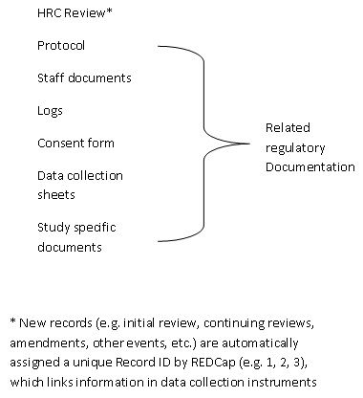Regulatory data is entered and stored in the eReg Binder Project in tandem with IRB reviews to facilitate the retrieval of data and generation of site specific reports. To ensure the project’s accuracy, all IRB reviews (e.g. initial, continuing review and amendments) should be entered into the project soon after submission and approval.

Main Form

Sub-forms for

**Figure 1: Data Collection Instruments (forms)**

The eReg Binder project contains 7 data collection instruments (forms). Each time a review is entered into the main “IRB review” form, general information is gathered that facilitates the identification and collection of related regulatory data in the 6 sub-forms (Figure 1). Related regulatory data is inputted and stored at the same time for a review.

Depending on the IRB review, sub-forms for regulatory data will display certain fields. For example:

|  |  |
| --- | --- |
| **If** | **Fields** |
| **Protocol summary was amended** | Protocol summary version date, # and copy |
| **Study is funded by an external source (e.g. NIH)** | Copy of significant correspondence with sponsor |
| **Written documentation of informed consent** | Consent form type, subject population, valid and expiration date |
| **Study involves collection, processing or analysis of specimens** | Laboratory name, type, document of qualifications (e.g. CLIA/CAP) |

To enter/store regulatory data for an IRB approved protocol:

1. Open the eReg Binder project
2. Click the 1st data collection instrument “**IRB review**” in the left navigation area
3. Click the “**Add new record**” button on the right side of the screen
4. Enter the review information. If you are starting the project, enter the information for the initial IRB review
5. Identify the form’s completion status using the drop down box under **Form Status**
6. Click “**Save and Go to Next form**” to proceed to the sub-form for regulatory data. Note, if the information in the sub-form does not apply to the review, the form will not display the related data entry fields (refer to table in this section’s introduction for examples).
7. Repeat steps 5 and 6 to enter/store remaining regulatory data
8. Repeat steps 3-7 for the next IRB review submission (e.g. continuing review/amendment)

# Sign-off on Delegated Tasks (Principal Investigators)

The study staff must already be added to the project to sign-off on delegated tasks. If the study staff was not added to the project, refer to the enclosed instructions for entering/storing regulatory data in section IV.

1. Open the eReg Binder project
2. Click the data collection instrument (form) “**IRB Review**” in the left navigation area
3. Select the IRB review that applies to the study staff (refer to record list for reviews)
4. Click the data collection instrument titled “**Logs**” on the left side of the screen
5. Check off delegated tasks
6. Check the box to activate e-signature
7. Enter username and password

# Develop Reports

The eReg Binder project contains 3 built in reports that approximate QI study management logs for tracking delegation of responsibility, protocol/consent form versions. Additionally, sites can develop reports that query, sort and combine review and regulatory data. These reports can be printed or exported to Excel.

## Generate QI Study Management Logs

1. Open the eReg Binder project
2. Go to “**Project Bookmarks**” in the left navigation area
3. Select the study management log (e.g. delegation log, consent tracking log, protocol version/amendment tracking log). Note: To view delegated tasks for all study staff, select “All records” from the drop down list

## Create Site Specific Reports

1. Open the eReg Binder project
2. Click the “Data Exports, Reports, and Stats” application in the left navigation area
3. Click the “Create New Report” tab
4. Enter a name for the report
5. Specify report users, fields, filters and sort order in steps 1 - 4
6. Click the Save Report button

# Additional Features

## Track Due Dates of Regulatory Documents

The eReg Binder project has a “calendar alert” feature that allows users to track the due dates of regulatory documents. Once a calendar alert is established, the due date is visible from the eReg Binder Calendar application. Due dates occurring in a week can also be viewed from the Project Home page. Any dates in the next few months can be viewed from the calendar itself. To establish a calendar alert:

1. On the left side of the screen, click on the Project Bookmark titled Calendar Alert
2. Enter a unique title for the alert (e.g. IRB Expiration Date)
3. Select the data collection form containing the date (e.g. IRB Review)
4. Select the date field (e.g. IRB Expiration Date)
5. Select the time field, if applicable
6. Add any notes that you would like to appear next to the date in the calendar
7. Click the option to enable the alert. This option can be modified at any time during the project.
8. Click “Save Configuration” at the top of the form to save the alert. To delete the alert click the red “X” in the upper right of the form. Please note, only dates in records that have a “Complete” status will be transferred to the Calendar application.
9. To view dates by month or year, click on the application titled “Calendar” on the left side of screen. To ensure that regulatory documents are current, the calendar should be viewed often (possibly at the start of every month). To view calendar dates in the upcoming week, go to the “Upcoming Calendar Events” section at the bottom of the Project Home page.
10. To create an alert for another date field, click on “Add another calendar trigger” at the top of the form and repeat steps 2-9 (if applicable).

## Display Status of Regulatory Documents

The Record Status Dashboard provides a snapshot of regulatory documentation for all IRB reviews. To view the Record Status Dashboard:

1. Open the eReg Binder project
2. Click on the Record Status Dashboard under “Data Collection” on the left side of screen
3. To view/edit regulatory documentation, click the buttons adjacent to the IRB review

## Search for Regulatory Data

1. Open the eReg Binder project
2. Click on the data collection instrument containing the regulatory data on the left side of screen
3. Select field to search using the field labels in parentheses
4. Enter specific criteria in search query text box

## Establish Links to Requirements/ Resources/Other REDCap Projects

Links can be established to federal regulations, institutional policies and Good Clinical Practice guidelines as well as to other REDCap Projects that gather data reported to the IRB (e.g. subject enrollment, protocol deviations and adverse events for the IRB approved protocol). To establish a link:

1. Open the eReg Binder project
2. On the home page, click the “Project Setup” tab
3. Scroll to the section “Set up project bookmarks”
4. Click the button “Add or Edit Bookmarks”
5. Enter a name for the requirement, resource or REDCap project
6. Enter the corresponding url address
7. Specify the type of link (e.g. simple link, REDCap Project). The default “simple link” connects users to web-pages outside of REDCap
8. Specify the users that will access the bookmarks
9. Click the “Add” button to the right of the link label

Examples of bookmarks that can be attached to this project:

|  |  |
| --- | --- |
| Name | URL |
| 45 CFR 46 | <http://www.hhs.gov/ohrp/humansubjects/guidance/45cfr46.html> |
| 21 CFR 312 | <http://www.accessdata.fda.gov/scripts/cdrh/cfdocs/cfcfr/CFRsearch.cfm?CFRPart=312> |
| 21 CFR 812 | <http://www.accessdata.fda.gov/scripts/cdrh/cfdocs/cfcfr/CFRSearch.cfm?CFRPart=812> |
| Good Clinical Practice (GCP) Guidelines | <http://www.ich.org/products/guidelines/efficacy/efficacy-single/article/good-clinical-practice.html> |
| REDCap Knowledge Base Help & FAQ | check with your REDCap administrator |